Abstract:

Image captioning is a task in computer vision and natural language processing that involves generating a textual description of an image. One approach to this task involves using a combination of a convolutional neural network (CNN) to extract features from the image, and a long short-term memory (LSTM) network to generate a sequence of words that describe the image.

The basic objective of an image captioning project using LSTM is to develop a model that can take an image as input and generate a natural language caption that accurately describes the contents of the image. The LSTM network is trained on a large dataset of image-caption pairs to learn the mapping between the two modalities, and is then able to generate captions for new images that it has not seen before.

Introduction:

The main problem in image captioning project is generating natural and accurate captions that effectively describe the content of the image. This is a challenging task because it requires the model to not only recognize the objects, scenes and context in the image, but also to generate a grammatically correct and coherent sentence that conveys the meaning of the image in a human-like manner.

Specifically, some of the main challenges in image captioning include:

1. Lack of diversity in training data: The quality of image captions generated by the model heavily depends on the diversity and quality of the training data. If the training data is not diverse enough, the model may generate generic captions that are not specific to the content of the image.

One possible solution is to use transfer learning, where the model is pretrained on a large dataset and fine-tuned on a smaller dataset specific to the task.

1. Ambiguity and variability in language: Natural language is often ambiguous and has a high degree of variability, which makes it challenging to generate captions that are both accurate and fluent.

Reinforcement learning can be used to optimize the caption generation process based on feedback from a human evaluator.

1. Incorporating context: Captions often require a certain amount of contextual knowledge to be accurate and meaningful. For example, the same object in different contexts may require different descriptions.

The use of recurrent neural networks (RNNs), specifically LSTMs, can help the model to maintain a long-term memory of the image content and generate captions that are coherent and consistent with the context.

1. Handling rare or unseen words: The model may not have encountered some of the words in the image caption during training, which makes it challenging to generate captions with rare or unseen words. One solution is to use word embeddings, which represent words as high-dimensional vectors in a continuous space. This allows the model to generalize to unseen words that are semantically similar to the ones it has seen during training.

Image captioning project is interesting and important for several reasons.

1. It is a challenging task that involves the fields of computer vision, natural language processing, and machine learning. Developing a model that can accurately describe the content of an image in natural language requires the model to have a deep understanding of both the visual and linguistic aspects of the task.
2. Image captioning has numerous practical applications, such as helping visually impaired individuals to understand and navigate their surroundings, and enabling automatic image annotation for large datasets.
3. Image captioning has the potential to help bridge the gap between humans and machines by enabling machines to understand and communicate with humans in a more natural and intuitive way. This can have far-reaching implications for a variety of fields, including education, healthcare, and entertainment.

Of course this is not just about emotional point of view but we do a feel a bit attached to this specific project because it is a challenging and important task in the field of Artificial Intelligence and Deep learning including various other concepts of Machine Learning that would help us to shape our future as a computer science engineer, and it has the potential to benefit society in many ways.

Literature Review:

To understand the image captioning project, one needs to have a good understanding of the following tools and concepts:

Computer vision: The project involves processing and understanding visual content, which requires knowledge of computer vision techniques such as object detection, segmentation, and feature extraction.

Natural language processing (NLP): The project also involves generating natural language descriptions of the visual content, which requires knowledge of NLP techniques such as language modeling, sequence-to-sequence models, and attention mechanisms.

Machine learning: The project involves training a model to generate captions from images, which requires knowledge of machine learning concepts such as supervised learning, unsupervised learning, and reinforcement learning.

Recurrent neural networks (RNNs): RNNs are a type of neural network that are well-suited for sequence-to-sequence learning tasks such as language modeling and machine translation. They are commonly used in image captioning projects to generate captions from images.

Long short-term memory (LSTM): LSTMs are a type of RNN that are designed to handle long-term dependencies in sequential data. They are commonly used in image captioning projects to maintain a memory of the visual content over long sequences of words.

Related Works:

Here are some of the significant works related to image captioning in chronological order:

**Show and Tell: A Neural Image Caption Generator by Vinyals (2015):** This was one of the first works to propose a neural network-based approach for image captioning. The authors used a CNN to extract image features and an LSTM to generate captions from these features.

**Deep Visual-Semantic Alignments for Generating Image Descriptions by Karpathy and Fei-Fei (2015):** This work proposed a model that aligns image regions with the corresponding words in the generated captions, resulting in more accurate and detailed descriptions.

**Neural Image Caption Generation with Visual Attention by Xu (2015):** This work introduced attention mechanisms into the image captioning model, allowing the model to selectively attend to specific regions of the image while generating captions.

**Show, Control and Tell: A Framework for Generating Controllable and Grounded Captions by Gan (2017**): This work proposed a model that allows users to control various aspects of the generated captions, such as the level of detail or the sentiment.

**Bottom-Up and Top-Down Attention for Image Captioning and Visual Question Answering by Anderson (2018):** This work proposed a model that uses both bottom-up (region-based) and top-down (global) attention mechanisms to generate more accurate and detailed captions.

**Generating High-Quality and Informative Conversation Responses with Sequence-to-Sequence Models by Zhang (2019):** This work proposed a model that generates informative responses to open-domain conversation questions, which can be seen as a related task to image captioning.

The state-of-the-art (SOTA) for image captioning is constantly evolving, and it depends on the specific evaluation metric used to measure performance. Some commonly used evaluation metrics include BLEU, METEOR, CIDEr, and ROUGE. The current SOTA models for image captioning typically use a combination of advanced techniques, such as multi-modal transformers, self-attention mechanisms, and reinforcement learning-based optimization.

There are several baseline methods and implementations available for image captioning. Some popular open-source implementations include:

1. Show and Tell implementation in TensorFlow: https://github.com/tensorflow/models/tree/master/research/im2txt
2. Neural Image Captioning implementation in PyTorch: https://github.com/karpathy/neuraltalk2
3. Self-Critical Sequence Training for Image Captioning implementation in PyTorch: https://github.com/ruotianluo/self-critical.pytorch

These implementations provide a starting point for building more advanced models for image captioning and can be used to benchmark the performance of new models against the baseline methods

Our whole project is not completely different from above related works because we have taken inspiration form various other projects in order to use anything that would help us to improve the efficiency of the model we are constructing. We have used InceptionV3 as our main CNN model, while we could have used VGG16 or VGG19 as well . We have also used embedding matrix created from Glove which was directly copied to the weights matrix of neural network.

So in a way we have tried our best to provide a model which differs from the existing ones and tried to improve the efficiency as well as the accuracy in predicting the most relevant captions for the test dataset that has been provided in the form of flicker8k dataset.

Methodology:

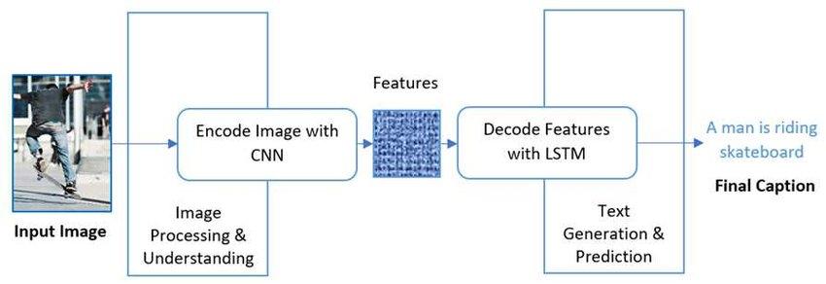

**This is the general methodology used in image captioning projects->**

**Data collection and preprocessing**: This involves collecting a dataset of images and their corresponding captions, and preprocessing the data to extract relevant features and convert them into a format that can be used by the model.

**Model selection and training**: This involves selecting an appropriate model architecture and training the model on the preprocessed data using an appropriate loss function and optimization algorithm.

**Hyperparameter tuning**: This involves tuning the hyperparameters of the model, such as learning rate, batch size, and regularization, to optimize the performance of the model.

**Evaluation**: This involves evaluating the performance of the trained model on a validation set using appropriate evaluation metrics such as BLEU, METEOR, CIDEr, and ROUGE.

**Inference**: This involves using the trained model to generate captions for new images and evaluating the quality of the generated captions.

**Fine-tuning**: This involves fine-tuning the trained model on new data or using transfer learning to adapt the model to new domains.

Network Structure:-

Image Encoder: We have used a convolutional neural network (CNN) to extract features from the input image. The output of the CNN is a fixed-length feature vector that represents the image.

Caption Decoder: In this we have used a recurrent neural network (RNN) that is used to generate a sequence of words that form a caption. The RNN takes the feature vector from the image encoder as input and generates a sequence of words one at a time.

Word Embeddings: This is a technique that is used to convert words into fixed-length vectors that can be used as inputs to the RNN. Word embeddings capture the semantic and syntactic relationships between words and help the RNN generate more accurate and meaningful captions. We have used glove embedding matrix in this project.

Loss Function:- The loss function typically involves measuring the dissimilarity between the generated caption and the ground truth caption. The loss function used in this project is the cross-entropy loss, which measures the difference between the predicted probability distribution over the vocabulary and the true probability distribution.

Regularization: Regularization is a technique used in to prevent overfitting, which occurs when a model performs well on the training data but poorly on the unseen data. In image captioning, regularization techniques are used to prevent the model from memorizing the training data and instead learning more general features that can be applied to unseen images.

The regularization technique that we have used in image captioning is dropout, which randomly drops out some of the neurons in the model during training. This helps prevent overfitting by forcing the model to learn more robust features that are not dependent on specific neurons.

Quality Metric: The quality metric used in image captioning is typically based on the evaluation of the generated captions compared to human-generated captions or ground truth captions. There are several popular metrics used in image captioning, including BLEU, METEOR, ROUGE, CIDEr, and SPICE.

Experimental Setup:

In general, image captioning experiments involve training a neural network model on a large dataset of image-caption pairs, and then evaluating the model's performance on a separate test set. The goal is to generate captions that are both accurate and descriptive of the visual content in the input image.

We have implemented this project on Google Colab platform made available by google itself which provides us with access to various libraries. By mounting colab notebook on google drive we were able to access the dataset which we have uploaded on our google drive.

We have used Flickr8k dataset for our implementation of the model. The Flickr8k dataset is a commonly used benchmark dataset for image captioning research. It consists of 8,000 images, each of which is paired with five different captions describing the visual content of the image. The dataset is widely used because it provides a diverse range of images and captions, allowing researchers to train and evaluate image captioning models on a variety of visual content. We have used 6000 images for training dataset and 1000 images for testing dataset.

Finding the best parameters for an image captioning model is an important step in the research process, as it can significantly affect the quality and accuracy of the generated captions. Here are some general steps that we followed while searching for the best parameters for our method and baselines in this project:

1. Defining the parameter search space: Before starting the search, it's important to define the range of possible parameter values that we want to explore. This can be done by specifying the possible values for each hyperparameter, or by using a more sophisticated approach like grid search or random search.
2. Selecting an evaluation metric: In order to compare different parameter configurations, we needed to select an evaluation metric that captures the quality of the generated captions.
3. Setting up a validation set: To evaluate the performance of different parameter configurations, we were required to set up a validation set of images and captions that is separate from the training and testing data. This helped us in comparing the performance of different configurations on unseen data and avoid overfitting.
4. Training and evaluating the model: Trained the model with different parameter configurations on the validation set, and evaluated the performance of each configuration using the chosen evaluation metric. Kept track of the results for each configuration, and selected the one with the best performance.

Source Codes:

Predicting new captions->

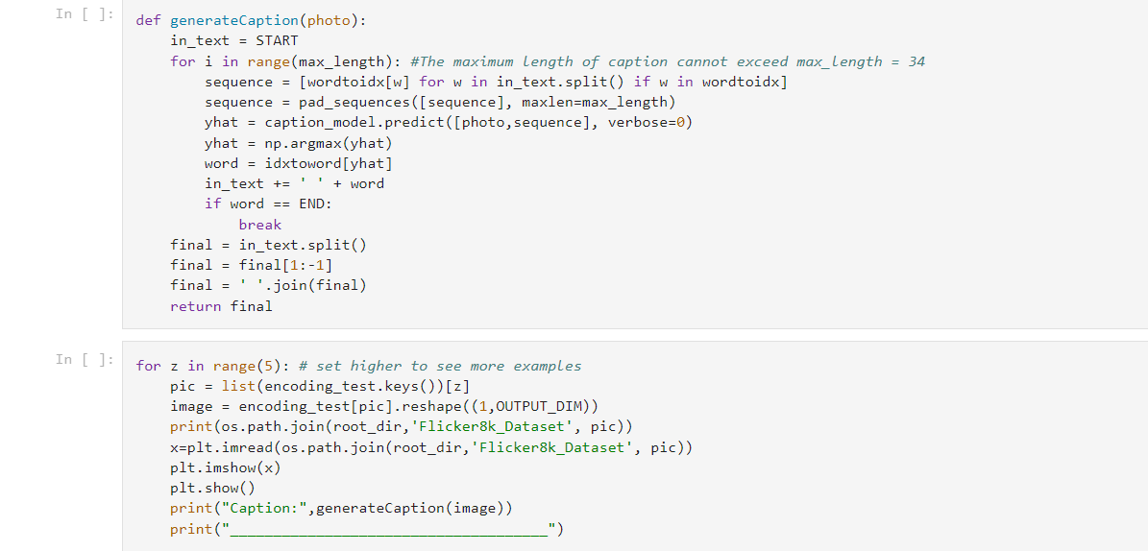

Data generating->

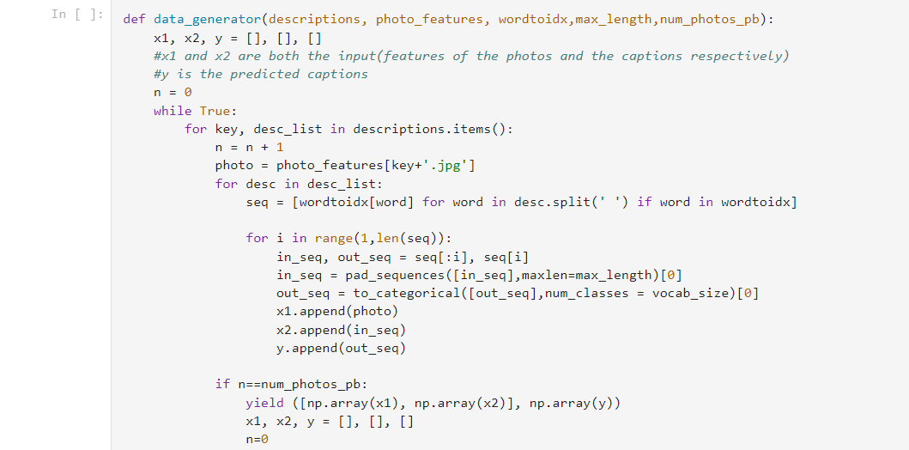

Glove embedding->

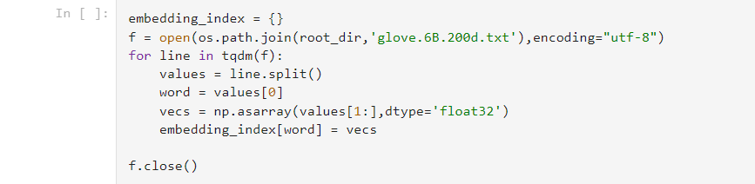

Model summary->

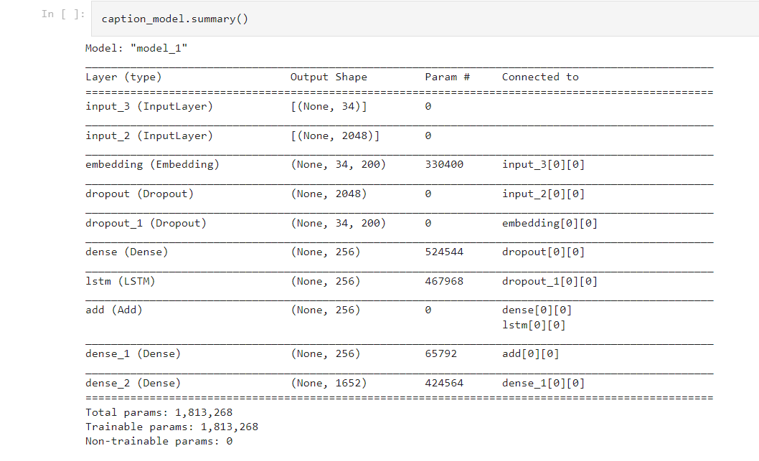

Results:

We were able to use the flickr8k dataset which contained over 8000 images and captions using which the results in the form of captions had close resemblance to the input images trained and tested in the model. We have provided the screenshots of the some images along with the output captions by the model.

